**NATIONAL INSTITUTE OF TECHNOLOGY**

**KURUKSHETRA**



**PRACTICAL FILE**

**SUBJECT :-** **Programming Using Python**

**BRANCH :- CS-A-01**

**ROLL NO :- 12112003**

**Submitted to:-**

**Shweta Pandey mam**

**Submitted by:-**

**Priyanshu maurya**

**Experiment-3**

1. (Algebra: solve quadratic equations) The two roots of a quadratic equation, for example, a $x^{2}$ + bx +c = 0, can be obtained using the following formula:

r1 = (-b + )/2a and r2 = (-b - )/2a

import math

print("ax^2+bx+c")

a = int(input("enter non-zero constant a: "))

b = int(input("enter non-zero constant b: "))

c = int(input("enter non-zero constant c: "))

d = b*b-4*a*a*c

if d < 0:

    print("No real root exists.")

elif d == 0:

    print("Roots are real and equal")

    print("and its value is: ", -b/(2*a))

else:

    print("Roots are real and distinct")

    print("and its values are: ", (-b+math.sqrt(d)) /(2*a), " ", (-b-math.sqrt(d))/(2*a))

OUTPUT

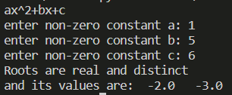

1. (Algebra: solve 2*2 linear equations) You can use Cramer's Rule to solve the following 2*2 system of linear equation:

ax + by = e x = (ed - bf)/(ad - bc)

cx + dy = f y = (af - ec)/(ad - bc)

Write a program that prompts the user to enter a, b, c, d, e, and f and display the result. If ad - bc is 0, report that the equation has no solution.

print("ax + by = e")

a=int(input("enter the value of a: "))

b=int(input("enter the value of b: "))

e=int(input("enter the value of e: "))

print("cx + dy = f")

c=int(input("enter the value of c: "))

d=int(input("enter the value of d: "))

f=int(input("enter the value of f: "))

if a*d-b*c==0:

    print("There is no solution exists.")

else:

    print("Solution exists.")

    print("X = ",(e*d-b*f)/(a*d-b*c))

    print("y = ",(a*f-e*c)/(a*d-b*c))

OUTPUT

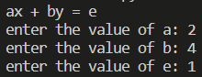 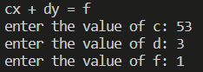 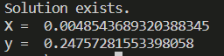

1. Write a program that generates two integers under 100 and prompts the user to enter the sum of these two integers. The program then report true if the answer is correct, false otherwise.

import random

a = random.randrange(1, 100)

b = random.randrange(1, 100)

print("a = ", a)

print("b = ", b)

sum = int(input("Enter sum of these 2 values : "))

if sum == a+b:

    print("your answer is correct.")

else:

    print("YOur answer is wrong.")

OUTPUT

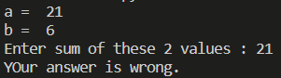

1. Write a program that prompts the user to enter an integer for today's day of the week (Sunday is 0, Monday is 1…, and Saturday is 6). Also prompt the user to enter the number of days after today for a future day and display the future day of the week.

day_no = int(input("Enter an integer for today's day of the week (Sunday is 0, Monday is 1…, and is 6) : "))

if day_no>6:

    print("Incorrect day number.")

    exit()

week = ['Sunday', 'Monday', 'Tuesday', 'Wednesday', 'Thursday', 'Friday', 'Saturday']

days_left = int(input("Enter no of day left in this week : "))

print("Next", days_left, "days are given below : ")

for i in range(days_left):

    print(week[(day_no+i+1) % 7])

OUTPUT

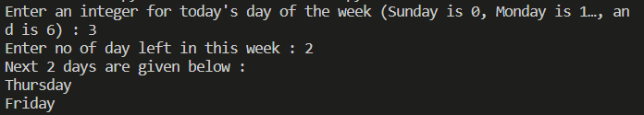

1. Suppose you shop for rice and find it i two different sized packets. You would like to write a program to compare the costs of the packages. The program prompts the user to enter the weight and price of each package and the displays the one with the better price.

print("Packet 1")

w1 = int(input("Enter weight of packet 1: "))

c1 = int(input("Enter cost of packet 1: "))

print("Packet 2")

w2 = int(input("Enter weight of packet 2: "))

c2 = int(input("Enter cost of packet 2: "))

if w1*c2 == w2*c1:

    print("Both packets are of same worth.")

elif w1*c2 > w2*c1:

    print("Packet 1 is of better price.")

else:

    print("Packet 2 is of better price.")

OUTPUT

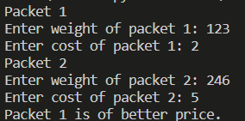

1. (Find the number of days in a month) Write a program that prompts the user to enter the month and year and displays the number of days in the month. For example, if the user entered month 2 and year 2000, the program should display that February 2000 has 29 days. If the user entered 3 and year 2005, the program should display that March 2005 has 31 days.

days = [31, 28, 31, 30, 31, 30, 31, 30, 31, 30, 31, 30]

months = ['January', 'February', 'March', 'April', 'May', 'June', 'July', 'August', 'September', 'October', 'November', 'December']

month = int(input("Enter the month number (1-12) : "))

year = int(input("Enter the year : "))

if year % 400 == 0 or (year % 100 != 0 and year % 4 == 0):

    days[1] = 29

print(months[month-1], "has", days[month-1], "days")

OUTPUT



1. Write a program that prompts the user to enter an integer and check whether the number is divisible by both 5 and 6, divisible by 5 or 6 or just one of them (but not both).

n = int(input("Enter an integer :"))

if n % 5 == 0 and n % 6 == 0:

    print(n, "is divisble by both 5 and 6")

elif n % 5 or n % 6 == 0:

    print(n, "is divisble by 5 or 6")

else:

    print("Not divisble by 5 or 6 or 5 and 6")

OUTPUT



1. Write a program that prompts the user to enter a hex character and displays its corresponding decimal integer.

hexa = input("Enter hexadecimal characters : ")

print("decimal representation of given hexadcimal number is",int(hexa, 16))

OUPTUT



1. Write a program that reads three edges for a triangle and computes the perimeter if the input is valid. Otherwise, display that the input is invalid. The input is valid if the sum of every pair of two edges is greater than the remaining edge.

a=int(input("Enter first side of triangle : "))

b=int(input("Enter second side of triangle : "))

c=int(input("Enter third side of triangle : "))

if a+b<=c or a+c<=b or b+c<=a:

    print("Output is invalid.")

else:

    print("Perimeter of given triangle is",a+b+c)

OUTPUT

